BlueJ Download and Installation for Windows | 

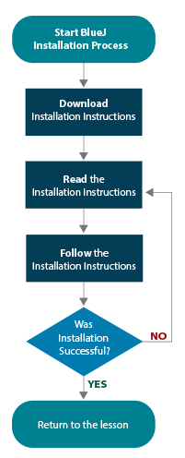
An overview of the BlueJ installation process is illustrated in the flowchart. If you have read through the instructions, you are ready for Step 4.

BlueJ installation is less complicated than Java; however, you must still follow the instructions carefully. You may want to check off each stage in the flowchart as it is completed.

Download the most recent official release instructions for BlueJ.

You should already have a basic knowledge of how to download files and create folders on your computer. If you do not, consult the Windows Help menu and learn the details you need to know.

- Go to the BlueJ website (http://bluej.org/) and spend a few minutes exploring the site.

- On the main page, locate the Download and Install section. Select the latest official release of BlueJ for Windows as shown below. Remember, you have already installed the Java JDK. At this time, you need only BlueJ. By the time you start the course, there may be a newer version of BlueJ. Download the newest version available. 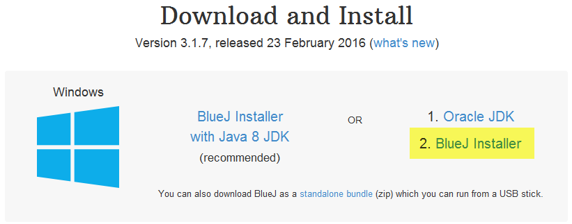

- Choose the Run option from the File Download window.

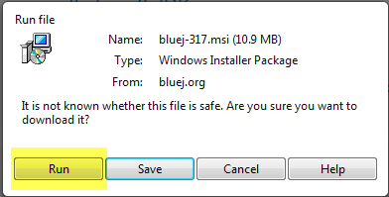

- The automated installer will take over from here. If any decisions need to be made, accept the default recommendations. This involves selecting Next multiple times.
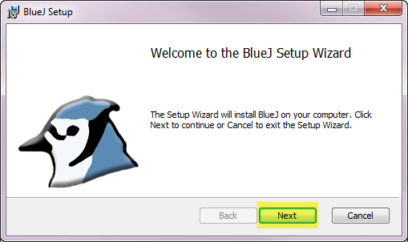

- Once all the defaults are set, select Install when prompted.
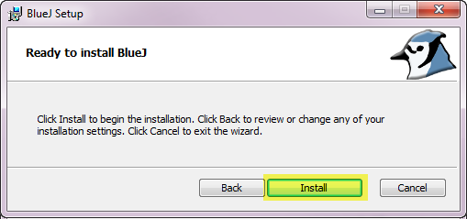

- Upon completion of the installation, select Finish.
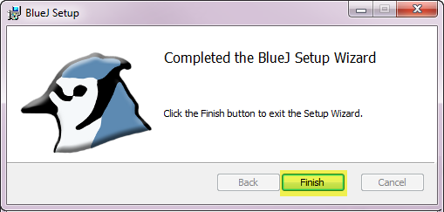

- When installation is complete, a BlueJ shortcut icon will appear on your desktop. Double-click on the BlueJ shortcut icon to launch the program.


- Answer "No thanks" to the Research Participation prompt.
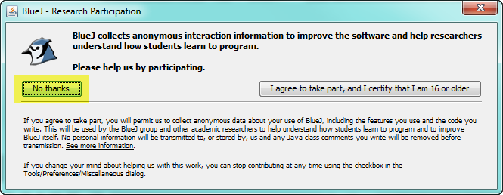

- When BlueJ launches correctly, you will see their opening image as the software loads. Once complete, a BlueJ window resembling the one below will open.

